# Seagal Box Office

Data Mining and Data visualization

Trine University 12/11/2024

# Data Set Link: [Steven Seagal Box Office - dataset by 14thlevelcleric | data.world](https://data.world/14thlevelcleric/caseys-money)

**Yearly Trend in the Number of Film Release**

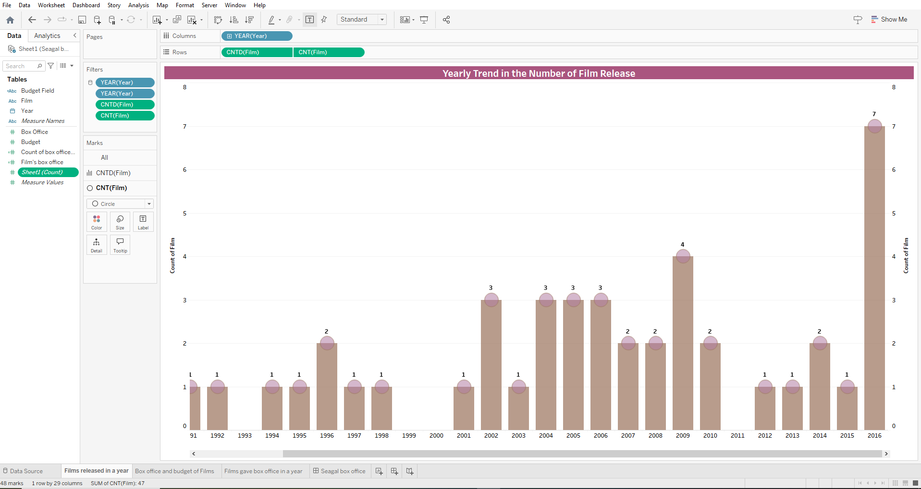

Figure Represents the number of films released every year

From the visualization, it is clear that there were periods in which Seagal was actively releasing films and at certain intervals there was less to show for.

It’s evident from the analysis there were peaks as well as valleys. The most productive times regarding the output of films occurred in between the years 2002-2009 as well as in the year 2016. These years show an unusual increase in the number of films which were most probably prompted by a good economic turnover or market demand. In contrast there are also years like 1991-1996 and 2003 that tell a different story, the production of films plummeted which could be due to the nature of the changing economic environment or even financial issues within the industry.

**Budget and Box Office of films on each year**

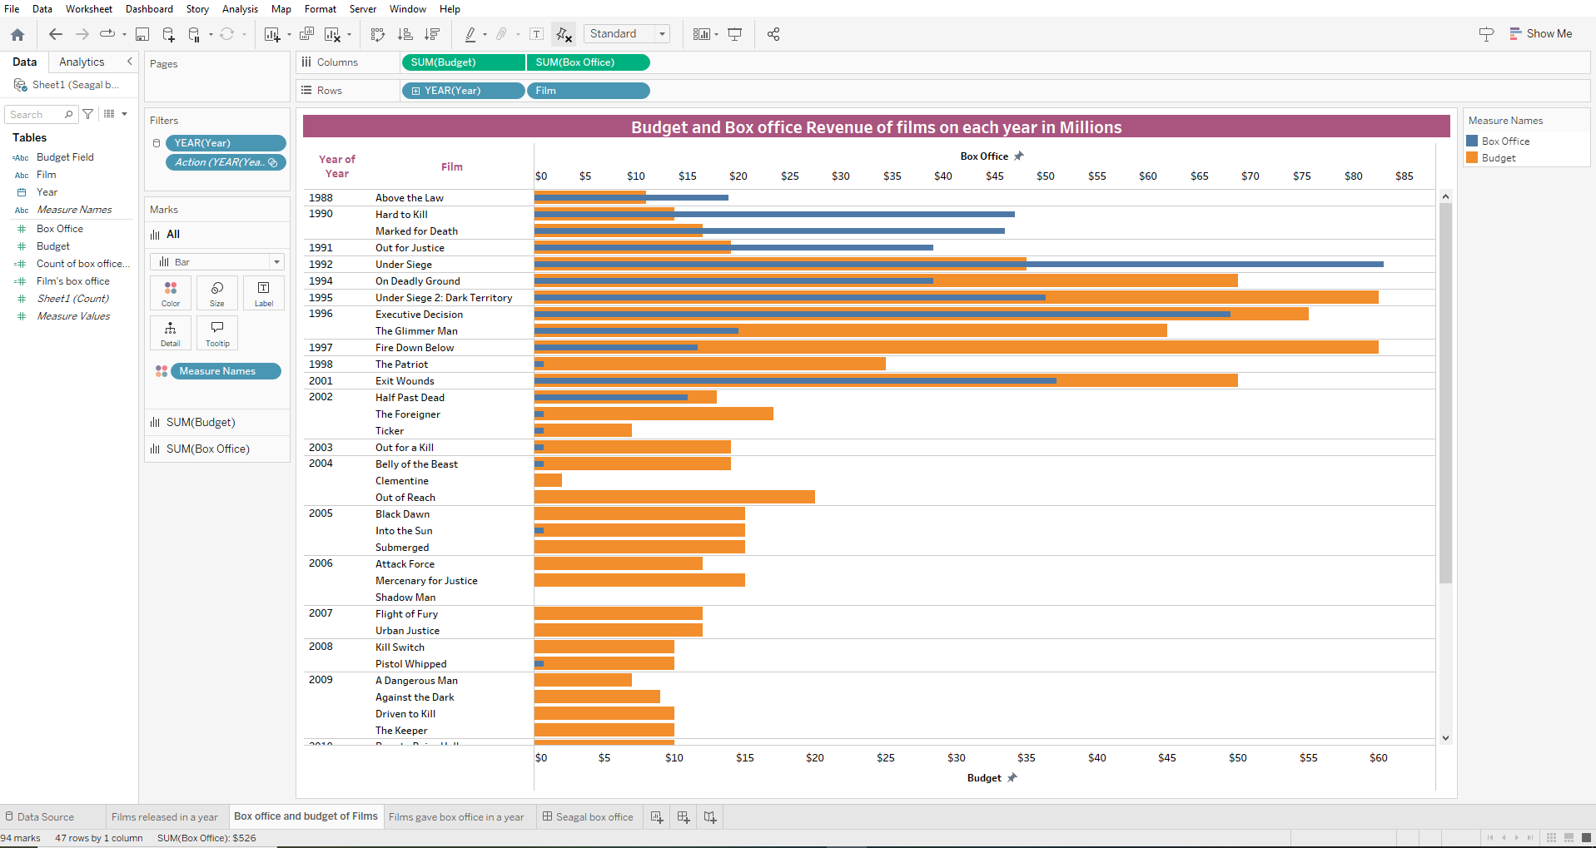

Figure Represent Budget and Box Office Revenues of Seagal Films

From the visualization it’s evident that some films tend to generate revenue in profits and other did not break even and led to losses after release. For example, the film Hard to Kill released in 1990 and Under Siege did remarkably well in generating profits surpassing break even points as compared to titles such as The Patriot and Out for a Kill led to losses as compared to the budget spent and revenue generated from box office Revenue.

**Budget of Every Film**

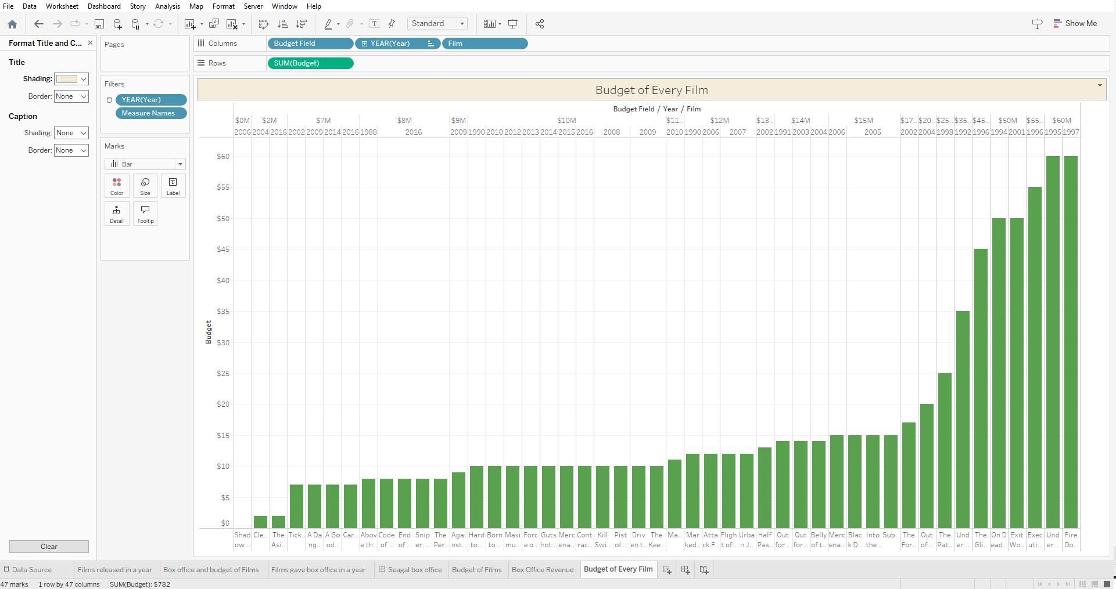

Figure Represents Budget of Every Film produce by Seagal

It’s evident from the visualization, that on average most films from Seagal ranges from $2M -$17M as compared to those that required high budgets some even reaching to a maximum of $60M.

**Trend in Budget of Films Over the Years**

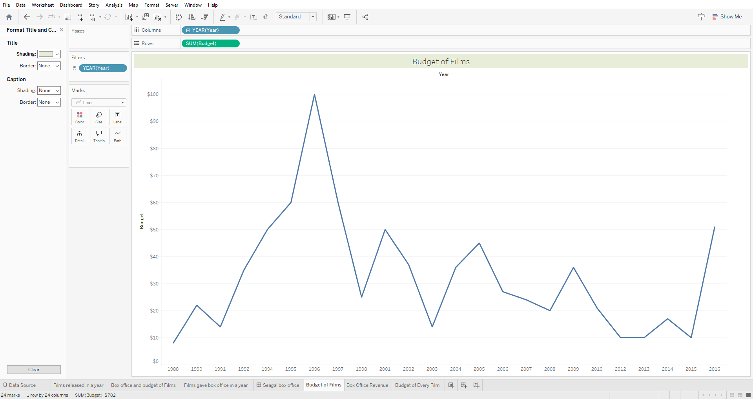

Figure Represents a Trend in Budget of Films Over the Years

From the visualization over the years its evident that there was a significant rise of budget from 1988 -1996 then a rapid plummet in budget over the other years making higher lows not surpassing the previous high.

**Trend in Box Office Revenue Over the Years**

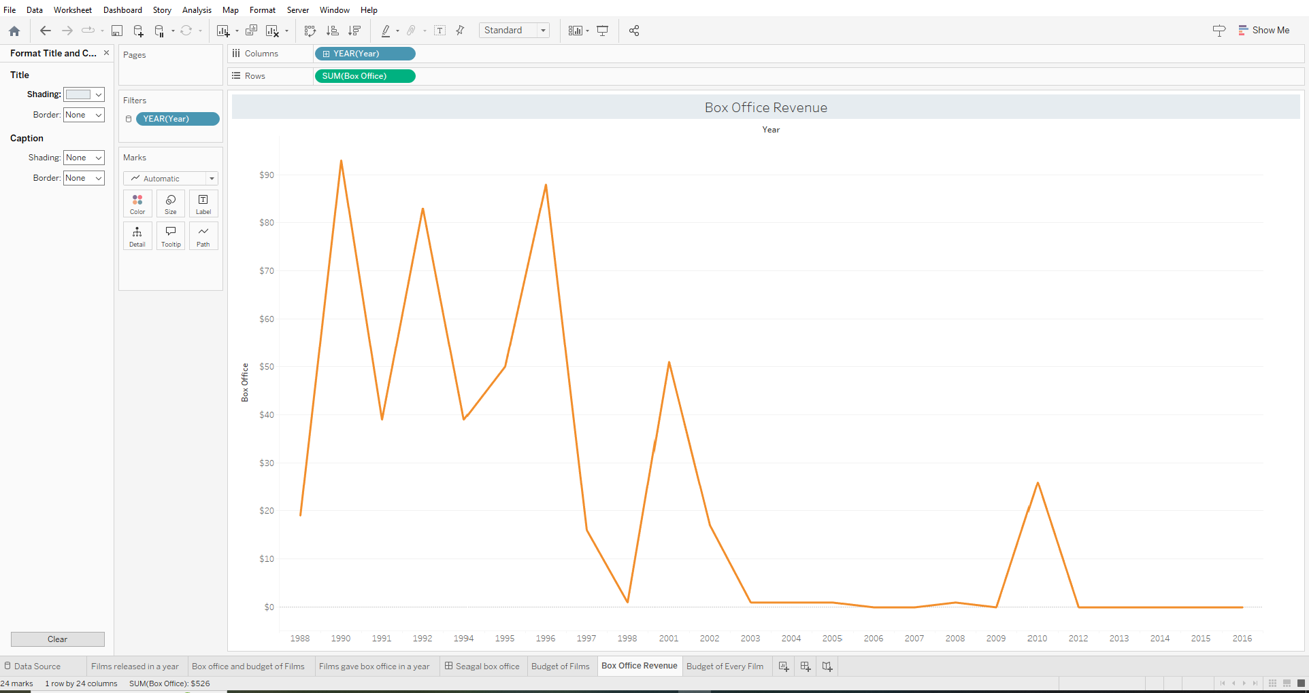

Figure Represents a Trend in Box Office Revenue Over the Years

It’s evident from the visualization that there is a significant drop in revenue generated over the years since 1996. Overall, there is a downward trend in revenue generated from Box Office

# References

* "Tableau Public: Data Visualization Cookbook" by Matt Francis and Ashutosh Nand Eshwar.